User Access FAQ
- How do I see who has roles in my district?
Open the Address Book from the button on the blue Main Menu.
- Who can add or modify users?
One or more district individuals can be assigned the User Access Administrator role to manage who can view and work in unapproved plans and grant applications for their district only. This person can add users, add and delete roles for a user, initiate a new password or modify user information for users in their district.
Any user can modify their own profile information- name, email address, phone numbers- and reset their passwords.
- Can a user have multiple roles?
Yes, a role is a permission set, not a job title. In some districts, a user may work with more than one funding application and would need roles for each one.
- Can multiple users have the same role?
Yes. For example, several people could have the same role that would give them the ability to work in an application.
- Can a user be deleted?
No. Because activities are tracked by user, all users stay in the system in order to maintain activity records. However, a user can be inactivated by removing all roles assigned to the user.
- Why didn’t a new user get an email to set a password?
If the email address for a new user is correct, it could be that the email was routed to a junk folder. If the email address for a new user is incorrect, the password email was sent to that incorrect address. In that case, the user access administrator corrects the email address and clicks the link to Reset Password to send a new password email.
- What are the permissions of the different roles?
Permissions are determined by 1) the district assigned and 2) the role assigned. District roles have permissions only for the district to which they have a role.
Role | Permissions
User Access Administrator | - Add users  - Assign roles  - Disable user accounts;  - View all approved and unapproved organizational data
LEA Superintendent/Authorized Rep | - Approve Funding Applications and Expenditure Reports  - Edit and submit any funding application or application supplement  - View all approved and unapproved organizational data
LEA Fiscal Representative | - Create and submit Fund Requests and Expenditure Reports  - Edit and submit any funding application or application supplement
LEA Grant Contact for {Grant Name} | - Edit and complete assigned funding application or application supplement  - View all approved and unapproved organizational data
LEA Data View | - Can view all data in the organization approved and unapproved
- Can a user work in multiple districts?
Yes. District User Administrators can assign a role for their district to any user in eGMS, even if that user is in another district. This is most often used in consortia. Search for the user and then assign the role.
- Must a person have a role to view the applications?
A person must have a user ID and appropriate role to view unapproved applications. Approved grant applications are visible to anyone, including the public.

Reviewing User Roles
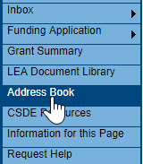
It is best practice to review the roles in your district annually to determine if changes need to be made. A quick way to see who has roles in your district is to access the Address Book.
Use the toggle link View All District Contacts to see the roles for each user.
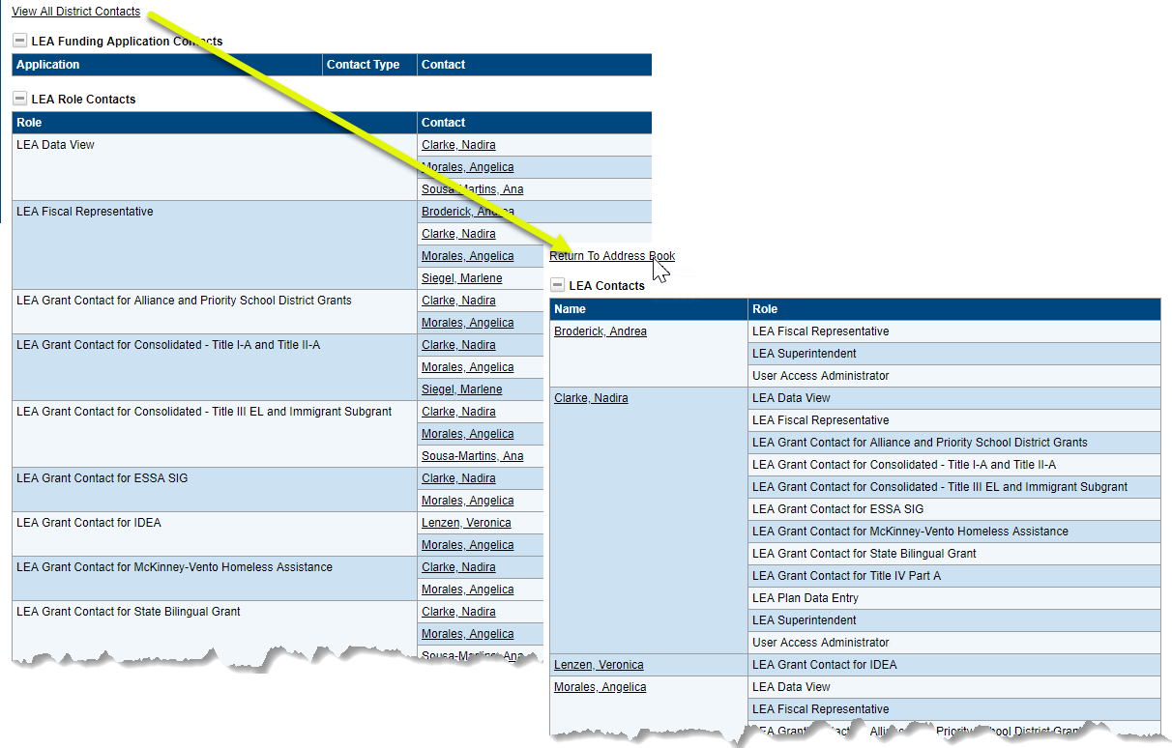

Creating New Users
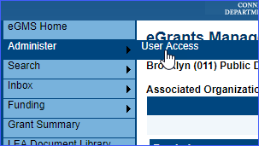
User Access Administrators will have Administer as an additional item on the menu. Select User Access from the Administer item.

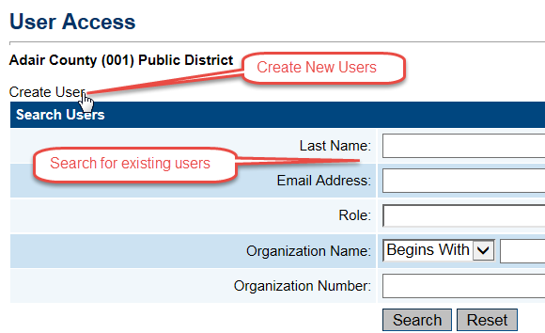
- The User Access page provides the ability to search for existing users using several filters – name, role, organizations.

- Click on the “Create User” link to open a screen to create a new user.

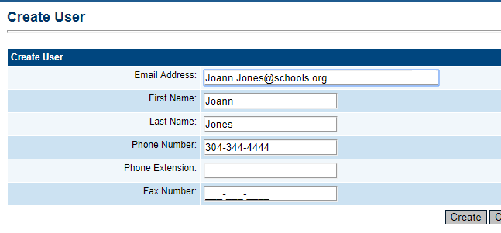
- Enter the email address, first name and last name. It is advisable to add a phone number if it is known. However, the user can add it later from the user profile. Click on “Create.” The system sends an email to the address permitting the new user to set a password.

- The system next displays the Create Role page.
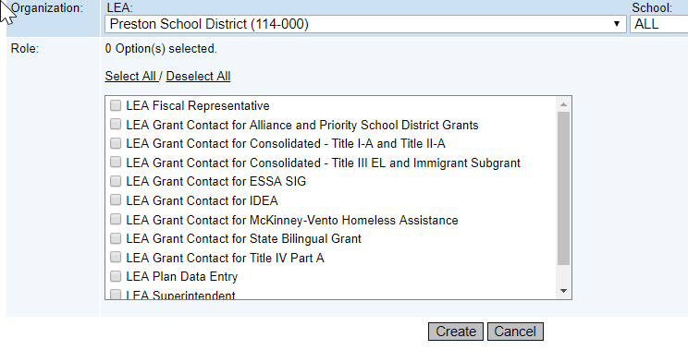
LEA user access administrators can only create roles for their own district. Select a role or roles for the user using the drop down box and click on the Create button. Note: for Grant application users leave the school selection at “ALL”. Schools are selected only for School Plan users.

Modifying and Removing Users

Correcting an email address
- If a user is added with an incorrect email address, DO NOT create a new user. Access the Search Users screen to search for the user. Select the user’s email address and correct the error on the next screen.

Changing roles
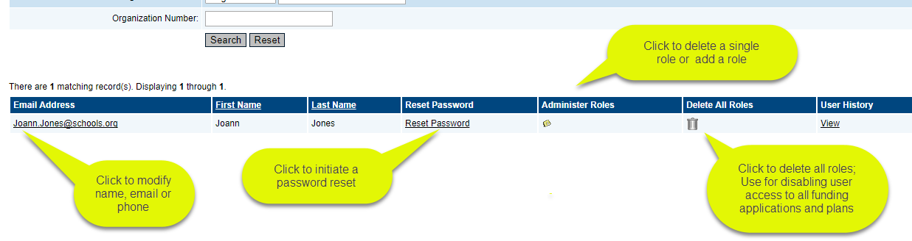
- To change, delete or add a new role for an existing user, use the search screen to locate the user.

- Click on the Administer Roles icon.
- From the Administer Role screen, you can add a new role by click on “Create Role” or delete an existing role by clicking on the trashcan icon beside the unwanted role.

Deleting a User
Users cannot be deleted from the system to preserve the integrity of audit records. However, by deleting all roles, their account is disabled, and they can no longer log in to eGMS. Click on the “Delete All Roles” trashcan icon to disable a user.

Updating a profile
Users can update their own profiles - change their name, email address or phone number - once they are logged into the system. However, a user access administrator can also modify the profile by searching for the user and clicking on the user email address from the search results.

Managing Passwords
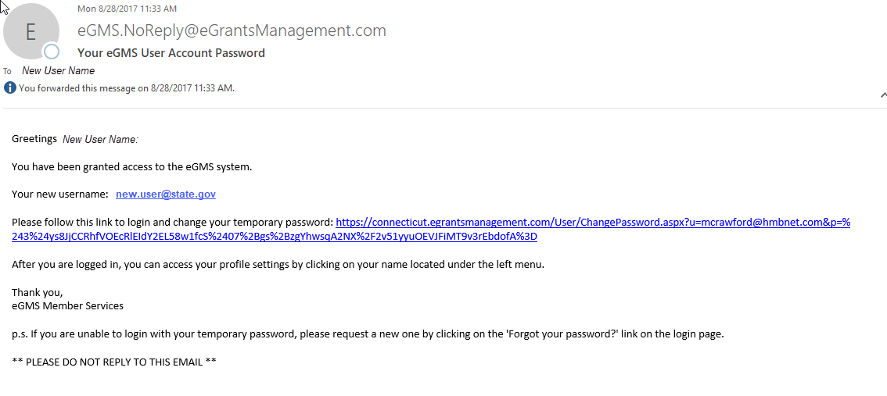
- New users are sent an email from the “eGMS.NoReply@eGrantsManagement.com” as soon as they are added to the system. This email allows them to set their own password.

- If users forget their password or want to reset their password, they can use the “Forgot your password?” link on the eGMS sign-in screen or, if they are logged in and wish to change their password, they can find the link by clicking on their name to bring up the user profile.
- User Access administrators can also generate a new password email by searching for the user and clicking on “Reset Password.” This is sometimes necessary if the first email was lost or the email address was incorrect.

Assigning users to multiple districts
- An LEA user access administrator can grant a role in their district to any user in the eGMS system.
- Search for the user. Click on the “Administer Roles” icon.
- Assign the user a role within your district. Note: User roles in other districts are not visible to District user access administrator and they can only modify roles for their district.

