LEA/Organization Fund Request (New Process)

The LEA/Organization Fund Assurance MUST be submitted at the beginning of each new fiscal year in order to process fund requests for the upcoming fiscal year.
- Log in as Superintendent/Authorized Representative.

- From the main menu, select Funding Applications, then Application Supplements. | 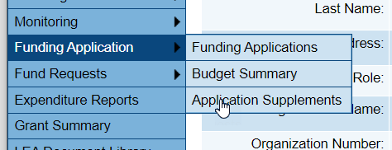
- Beginning with FY 2024, select the upcoming FY and select LEA/Organization Fund Assurance. | 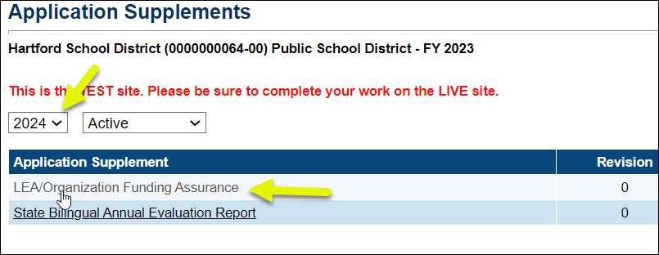
- Change the status to Application Supplement Started and Confirm | 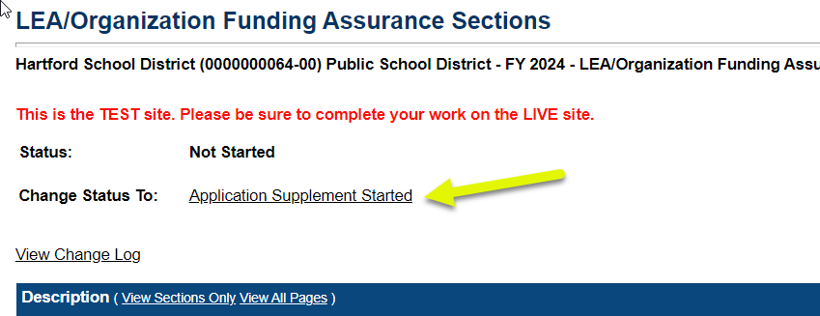
- Select the Program Details page. | 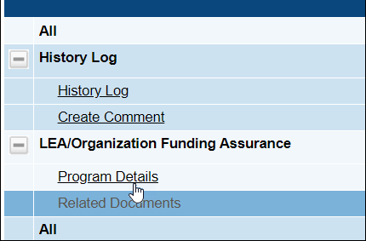

- Complete the Program Details page by entering information into ALL required fields. These are marked with an asterisk *.
Adding a second or third submitter is optional.
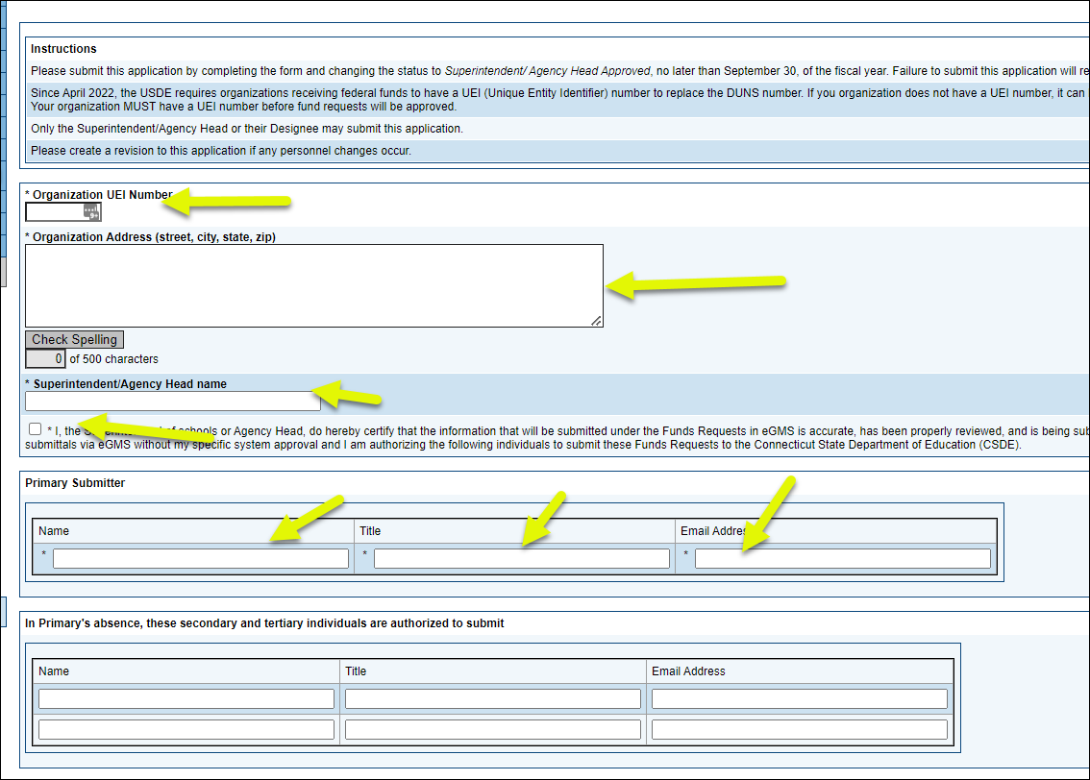
- Use the Save and Go To Button to return to the Sections page. | 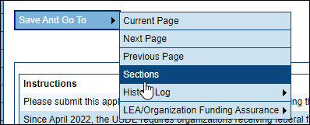
- Change the status to Application Supplement Completed. | 