Uploading documentation
- Grants and funding application frequently require additional documentation and forms to be submitted with an application. Generally the pages where this documentation is uploaded are called “Related Documents”, but they may have another title. They can be associated with a specific grant section, such as consortia “Intent to Participate” or a specific grant, or they can be a separate section related to the entire funding application. All uploaded files are saved permanently with the application.
- Documentation can be Optional or Required depending on the grant or depending on conditions in the grant. If the document is listed in a “Required Documents” section, you must upload one or more documents or you will receive an Error that prevents submitting the document. If the document is listed in a “Optional Documents” section, omission of a document may cause a warning, but won’t prevent submission of the application.
- These pages can upload Excel, Word, PowerPoint or PDF files. You can upload any number of documents. Some documentation will require the use of a template which is available for download on the page. The same upload process exists for all these pages.

Uploading a document that does not have a template
- Create the document and save it to your machine. If you are uploading a document with a required signature, scan the completed document and save it to the local machine.
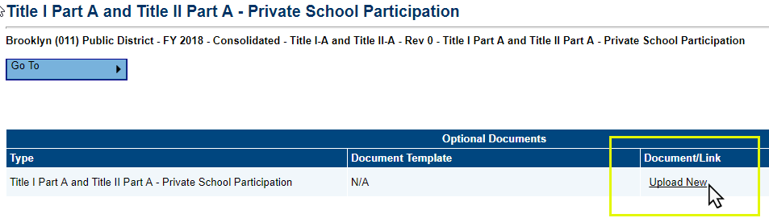
- Click on “Upload New” under Document Link.
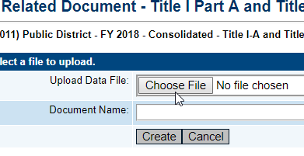
- On the screen that displays, click on “Choose File.” Locate the file on your computer, and click “Open.”
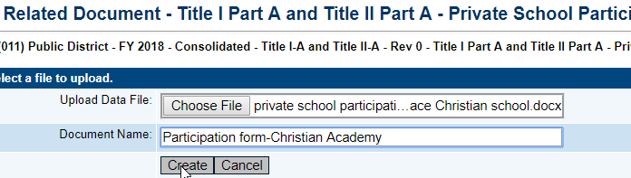
- Enter a Document Name that makes the file easy to identify and click on “Create.” The file appears as an icon with the name of the file.
- Click on Upload New again to upload a different document. Once uploaded, you can:
- Click on the name of the file to open it and view it.
- Click on Delete to delete the file.
- Click on Update to upload a new version of the file.

Uploading a document that has a template
- Click on the template name.
- Depending on your browser, it either opens the document or downloads the document. Check your download folder or look at the bottom left corner of your screen for a link to the file if it doesn’t open automatically.
- Click on “Enable Editing” on the opened file and complete it.
- If the document requires a signature, you will need to print the document, obtain the signature and then scan the document and save it as a PDF file.
Save the completed file or scanned PDF file to your computer. Once it is saved, upload using the directions above.

Updating an uploaded document.
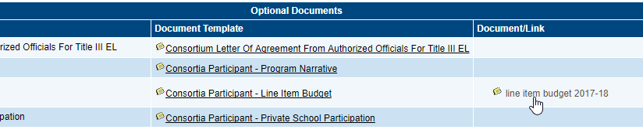
- Click on the uploaded document.

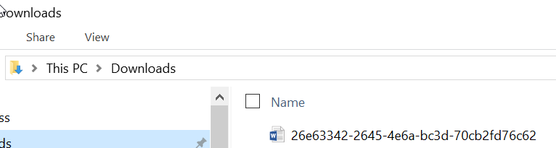
- The document will be downloaded with a name that has a series of letters and numbers. Click on the document or open it from the download folder.
- Make changes to the document and save the document with a name to your machine. You can use a new name or give it the same name as the previously uploaded file.
- On the Related Documents page, click on Update
- Click on Upload Data file and find the file that was just saved. DO NOT give the document a new Document Name. Click on Update and the new version will be loaded.

