Fund Request Instructions

- Select Fund Request from the main menu.
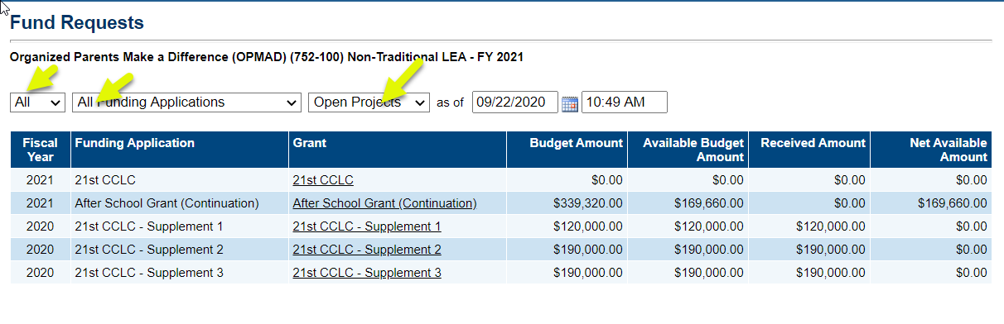
- Select the drop downs on Fund Requests to see ALL your available grants
- Click on the name of the grant for which you need to create a fund request.
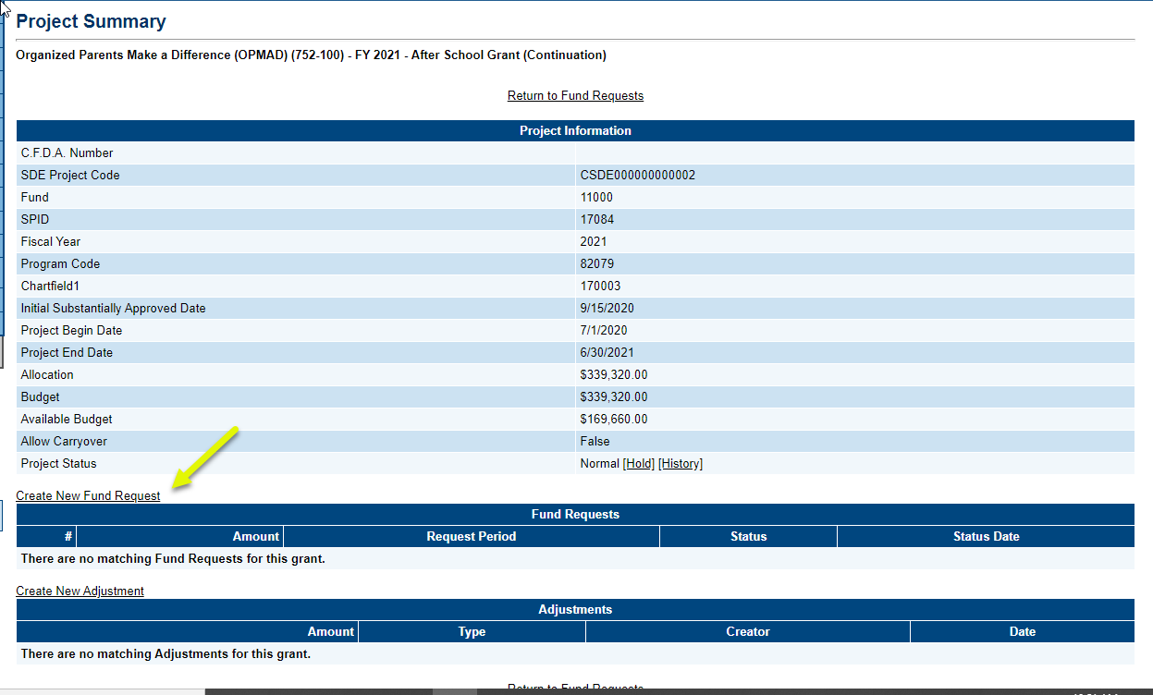
- On the Project Summary page click on Create New Fund Request and then click Confirm.

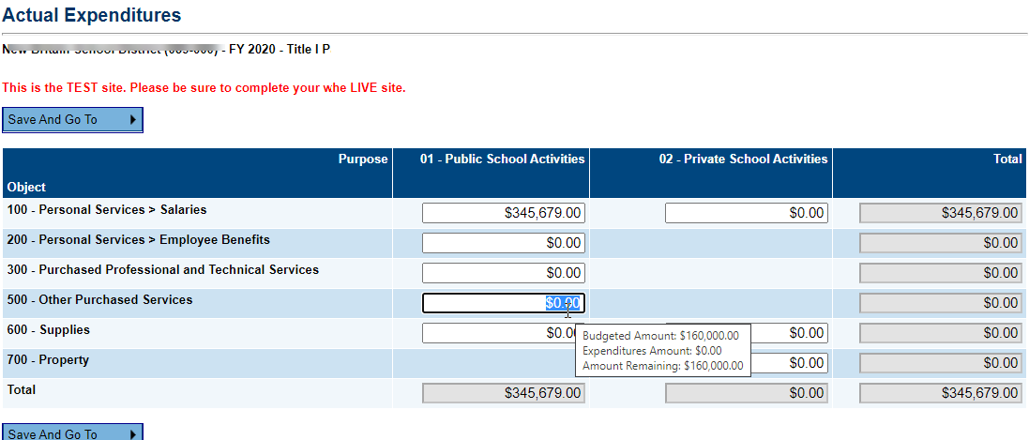
- The Sections page will display. If this is the first request of the current quarter, click on the Actual Expenditure page and enter/update the year-to-date expenditures. Hovering over the cells will provide as to the budgeted amount and amount remaining for the object code. Though you may complete this page with the fund request, updating this page is only required once a quarter, with the first request of the quarter.
Hover over the field to see the amount budgeted in the funding application. Grants that are over $100,000 cannot enter more than 110% of the budgeted amount for the object code. There is no restriction for grants under $100,000.

- On the Sections page or from the Save and Go To button, click on the Request page.
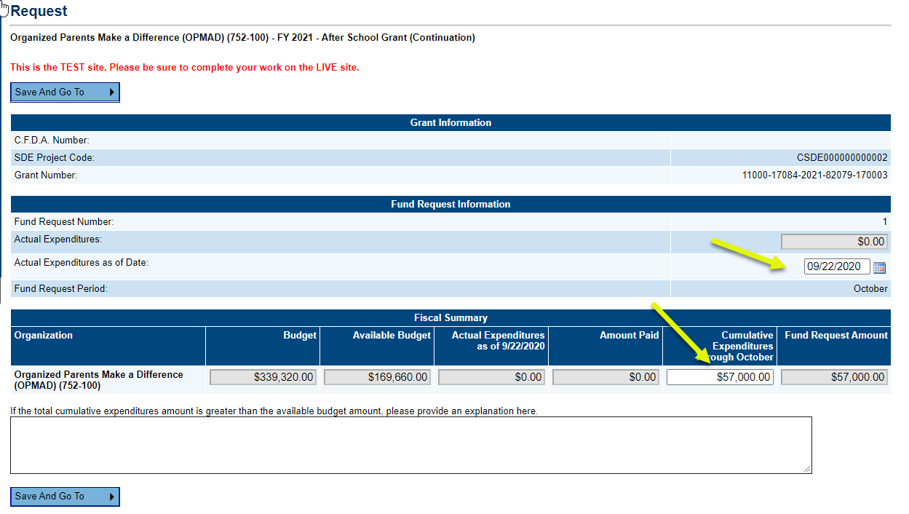
- Enter the date of the Actual Expenditures that are reflected on the Actual Expenditure page.
- Enter the amount of “Cumulative Expenditures through [Month}”. This is the amount of the Current Expenditures plus the amount you will need through the end of the current cycle.
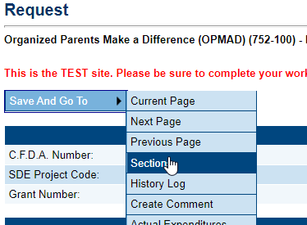
- Click on Save and Go To : Sections page.

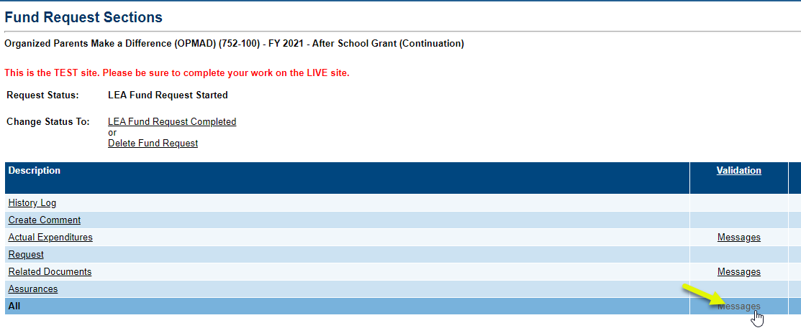
- Click on Messages to see if there are any red ERROR messages. If there are no errors, return to the section page.

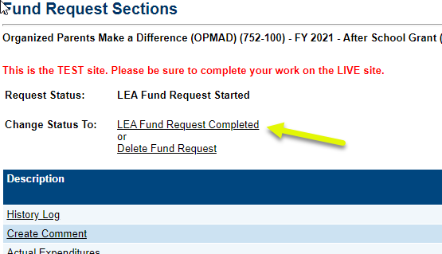
- Click on the status Fund Request Completed to finish the fund request.

