Connecticut eGMS Fund Request Manual
Updated July 1, 2023.

Contents
I. Fund Request Process 1
A. End of Fiscal Year/State Grant Processing 1
B. Federal Grant processing 2
C. Other restrictions 2
II. Fund Request Screens 3
III. Steps for Creating a Fund Request 8
IV. Using the Search Fund Request Feature 11

Fund Request Process
Fund Requests are the mechanism for districts and organizations to request funds from their grant allocations. Currently, CSDE allows fund requests to cover existing actual expenditures. Beginning July 1, 2023 and forward, fund requests are REIMBURSEMENT ONLY.
Fund requests can be submitted at any time. CSDE and OEC collect submitted fund requests weekly into a file that is then sent to Connecticut’s CORE-CT payment system. Once it is processed by CORE- CT, that system makes payments to the organizations and the fund requests that were submitted are changed to the status of State Accounting System Paid.
Before a fund request can be submitted, the LEA/Organization Funding Assurance MUST be completed for the current FY.
The primary status sequence of a fund request is as follows:
- “LEA Fund Request Started”- initiated by the LEA Fiscal Representative by creating the request
- “LEA Fund Request Submitted” - changed by the LEA Fiscal Representative has completed the request
- ” CSDE/ OEC Fiscal Approved” OR “CSDE /OEC Fiscal Returned-Edits Needed” '- changed by CSDE/OEC fiscal staff
  - If returned, the LEA Fiscal Representative makes corrections that are noted in the History Log and changes it back again to “LEA Fund Request Submitted.”
- “Submitted to State Accounting System” – changed by CSDE/OEC fiscal staff
- “State Accounting System Paid” – changed by CSDE/OEC fiscal staff

Federal Grant processing
Federal grants have a 60-day liquidation period by which fund requests can be started for expenses prior to the grant’s end date. For federal grants, there is no time frame for payment as long as it is started within 60 days of the liquidation period following the end of the grant. If it is not completed in time for the current cycle, it will just need to wait until the next.
TIP: If a federal grant is ended, be sure to select the status of “Closed” on the Fund Requests screen (see below) to find these grants.

Other restrictions
- Fund requests cannot be made until the original (Rev 0) funding application containing the grant is in “CSDE/OEC Fiscal Approved” status. The status of an application can be viewed on the Funding Applications screen accessible from the blue main menu.
- Fund requests can only be created by users with the Fiscal Representative role. Check the Address Book on the blue main menu to see who has this role in an organization.
- Only one request for a grant can be submitted at a time. You can do multiple fund requests in a month, but note that your prior fund request must be in a paid status before you can start your next request.
- A fund request may be returned to the LEA by the OEC/CSDE Fiscal staff for correction. Be sure to watch for the status of “Returned” and check the History Log for the reason for return.
- Fund requests for state grant funds must be submitted so that they are processed prior to the grant’s end date. For example, most state grants end on 6/30 of the fiscal year. Because funds cannot be paid after 6/30, the fund request must be in Fund Request Submitted status by early June to assure that they can be paid prior to the end date. There is a message every month on the eGMS Home Page that provides the date by which fund requests must be submitted to ensure payment.

Three steps are necessary for a Fund Request to be completely submitted by the organization for payment.
- Create Fund Request
- Complete the pages in the Fund Reqest by updating the cumulative expenditures on the “Expenditures” page and entering an As of Date.
- Change the status to LEA Fund Request Submitted. It must be in this status to be reviewed by the state and included in the monthly file.

Fund Request Screens
Fund Requests Screen
The Fund Requests screen displays fiscal details of the district’s funding applications and is where you will select a grant from which to make a fund request. The drop-down fields at the top of the list give the ability to filter the list of funding applications has by fiscal year, funding application and open/closed status.
The most comprehensive list of open applications can be achieved by using “All” for fiscal year and “All Funding Applications.”

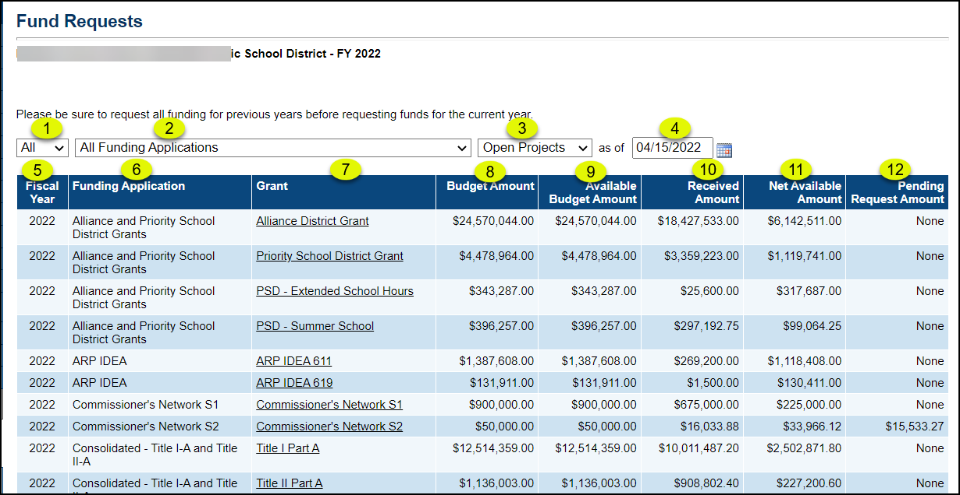

Page Item | Description
- Fiscal Year | Restricts the list to applications in a specific fiscal year.
- Funding Application | Restricts the list to a specific Funding Application. While funding requests are made against a grant, selecting a funding application will list all the grants within it.
- Project Status | Use to view Open and Closed projects.  Tip: Set to “Closed” to find federal grants since fund requests for federal grants can be made up to 60 days after a grant has closed (ended).
- As of Date | Use to define open projects and closed projects more narrowly.
- Fiscal Year | Identifies the fiscal year of each funding application/grant.
- Funding Application | Identifies the name of the funding application
- Grant | Identifies the grant within the funding application. Click on the grant name to view/edit/ create a fund request for the grant.
- Budget | Displays the amount of the budget for the grant.  If an open grant shows a budget amount of $0.00, that means the funding application containing the grant has not reached “CSDE Fiscal Approved “status.
- Available Budget Amount | Available Budget shows the amount of the budget that is available for fund requests at the current time. CSDE can restrict the amount of grant funds available during a grant period. For example, state grant funds are restricted to 25% per quarter of the grant life.
- Received Amount | Displays the amount the district has already received from the grant
- Net Available Amount | Displays the amount available for fund requests at the current date (Available Budget Amount- Received Amount)
- Pending Request Amount | Displays the amount of any open Fund Request (a fund that has been submitted but is not yet in “State Accounting System Paid” status)

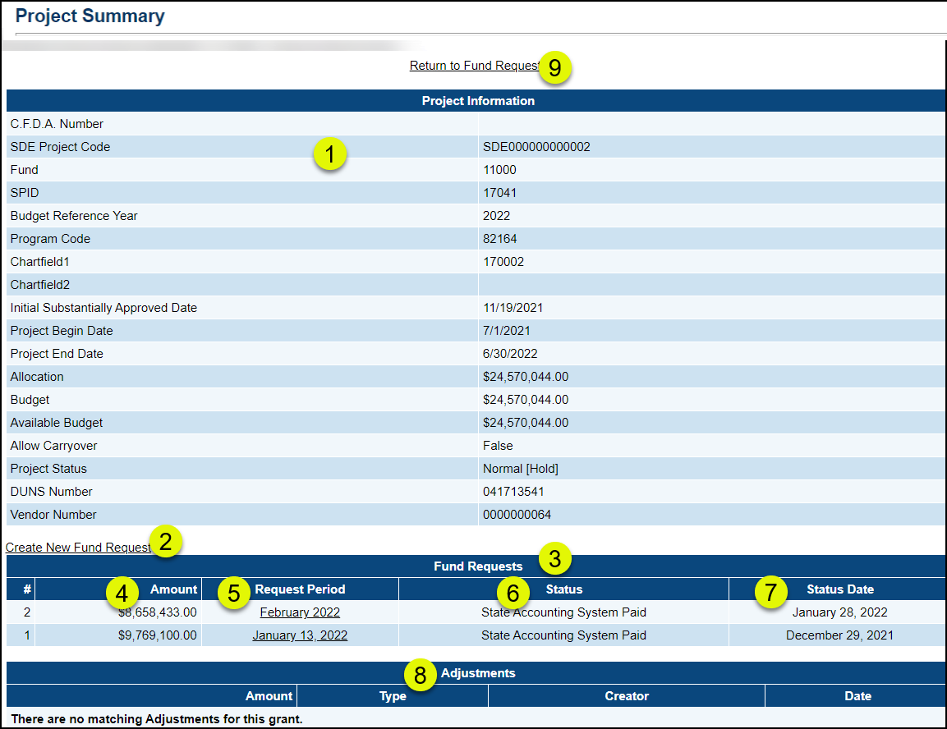
The Project Summary screen is where a new fund request is created and displays a record of all the fund requests for a grant, in addition to grant information.
Page Item | Description
- Project Information | Displays non-editable information about the grant, including the project code numbers.  Project status indicates whether fund requests are allowed for the grant. A status of HOLD is very rare but indicates that fund requests may not be made. Contact SCDE if there is a Hold on the grant.
- Create New Fund Request | Link to create a new fund request. If the link does not appear, it is for one of the following restrictions:  User does not have permission. Fund requests can only be created by fiscal representatives.  The original (Rev 0) funding application does not have “CSDE Fiscal Approved” status.  A fund request has been started or a fund request has been paid during the current request period for this grant. Only one request can be submitted during a request period.  State grant funds lapse after 6/30. Fund requests started on 6/30 cannot be paid as funds are no longer available. State funds must be requested in advance of the 6/30 end date.  Fund requests cannot be created for federal grants after 60 days past a grant’s end date.  The grant is not paid through the eGMS system; it is paid by some other means outside of eGMS.
- Request Number | Identifies the fund request number. A grant’s fund requests are sequentially numbered.
- Amount | The requested amount of a fund request
- Request Period | The month in which the request is being made.
- Status | The status of the fund request. The primary statuses are:  - LEA Fund Request Started  - LEA Fund Request Submitted  - CSDE/OEC Fiscal Approved/or Returned- Edits Needed  - Submitted to State Accounting System or Returned to CSDE/OEC Fiscal Approver  - State Accounting System Paid
- Status Date | The date of the last status change for all previous fund requests.
- Adjustments | Used by CSDE or OEC to make corrections to the balance of a grant.
- Return | Returns to the Fund Requests screen page.

- The Fund Request Sections screen is the first screen of the actual fund request. It has links to the pages and is where status changes are made, error messages are displayed, and where printing is initiated. State Accounting System Paid

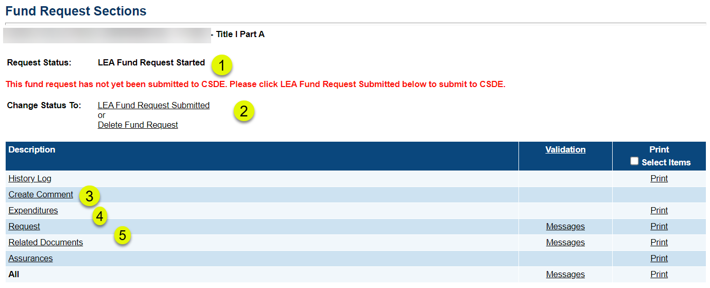

Page Item | Description
- Request Status | The fund request begins in “LEA Fund Request Started” status.
- Change Status to: | After the “Request” page has been completed, the status MUST be changed to “LEA Fund Request Submitted” to send it to the state for payment.  If the fund request was started by mistake or if it has been open a long time, it can be deleted. This will allow you to create a more up-to-date request.
- History Log/Create Comment | The “History Log” is a record of the different status changes and comments. It records the user and timestamp of the actions.  Create Comment is a place where any user can enter notes. If a fund request is returned to the district, the reason will be entered here and displayed in the “History Log.” District users may also use the Create Comment for any additional information that they may want to include. It is optional, however.
- Expenditures | Enter actual expenditures as of the date the fund request is being submitted.
- Request | Data for the actual amount of the request and entry of date that expenditures have been incurred.
- Validation | Click Messages links to see any errors or warnings
- Print | Select print for all or for individual pages. (See Printing in the Training and Video Links area on the eGMS Home page for the exact printing process)
Note: Assurances and Related Documents | Assurances is a statement but does not require action.  Most grants do not require any further documentation, but there are one or two that do require it. An error message will occur if it is not loaded.

Steps for Creating a Fund Request

- Go to Fund Requests/Fund requests. This will display the Fund Requests page. | 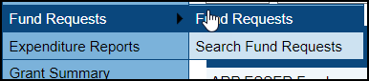
- On the Fund Requests page, use the drop downs to locate the funding application containing the grant for which you are creating the request, OR select “All” for fiscal years, “All Funding Applications” and “Open Projects” to see all active grants.  Click on the name of the grant for which you are creating the fund request.  This will take you to the Project Summary page. | 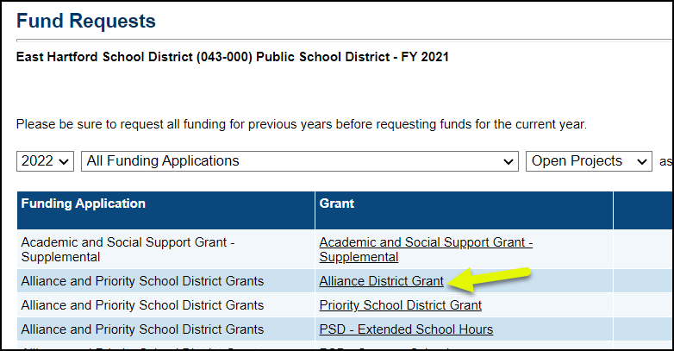
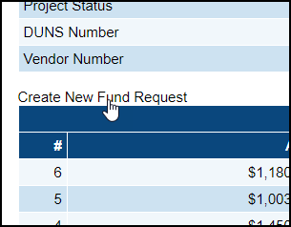
- Click on “Create New Fund Request.” Then click on “Confirm” on the next screen. This will take you to the Fund Request Sections screen
If the link does not appear, it is for one of the following restrictions:
- User does not have permission. Fund requests can only be created by fiscal representatives.
- The original (Rev 0) funding application does not have “CSDE Fiscal Approved” status.
- There is an existing fund request for the grant that is not in the status of “State Accounting System Paid.”
- The allowable dates for requesting funds have passed.
- Fund requests are no longer accepted. NOTE: State funds lapse after 6/30, no exceptions. Though the link may appear, a fund request started on 6/30 cannot be paid even if completed on 6/30 as the State Comptroller’s Office has stopped accepting payments for the FY by this date.
- Fund requests cannot be created for Federal Grants after 60 days past a grant’s end date.
- The grant is not paid through the eGMS system; it is paid by some other means outside of eGMS.

- On the “Fund Request Sections” page, click on the “Expenditures” link. Updating this page is REQUIRED for a fund request.
- On the Expenditures page, enter the most recent expenditures in the object codes. Hovering the mouse over the entry fields will create a pop-up window, showing the amount budgeted in the last approved application, the amount already received and the amount remaining. All actual expenditures are cumulative from the start date of the grant through the actual expenditure As Of Date
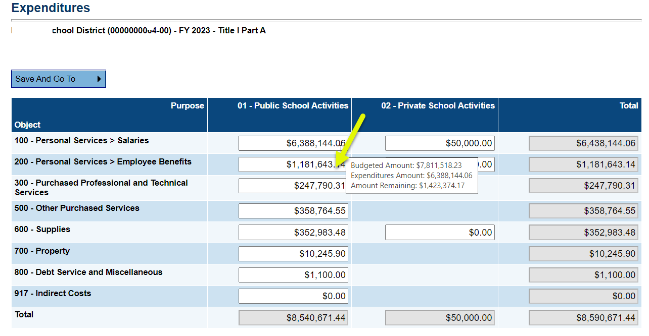
- After completing the l Expenditures page, click on Save and Go To button and select “Request” page.

The Request screen will automatically populate from the Expenditures page and will display the amount of the request.
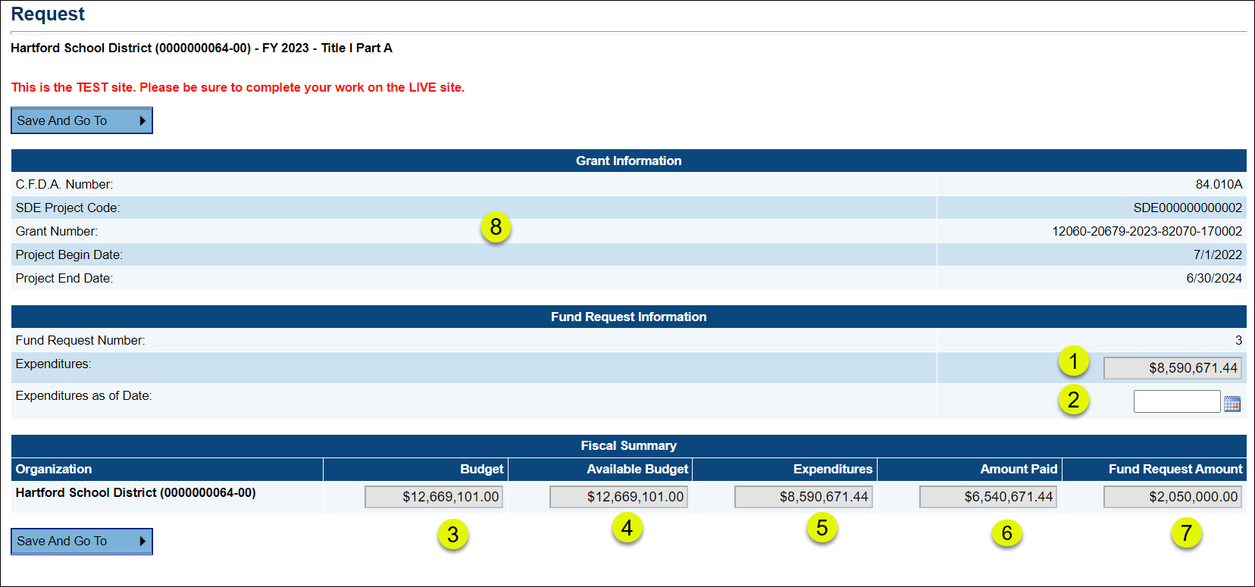

Page Item | Description
- Expenditures | Auto populated and non editable amount from the Expenditures page
- Expenditures as of Date  REQUIRED | Date of the actual expenditures, it is appropriate to use the current date. A required field. Make sure your expenditures match the date entered.
- Budget | The full budget that is in the grant’s current approved funding application and is system populated
- Available Budget | The funds that are currently available as set by CSDE. (State funds are available at 25% per quarter and is system populated.
- Expenditures | Expenditures from the total of the Expenditures page- system populated.
- Amount Paid | Sum of the previous paid fund requests for the grant
- Fund Request Amount | System calculated. (“Cumulative Expenditures” – “Amount Paid”). This must be greater than 0.
- Grant Information | Grant codes plus start and end date of the grant.

- Complete the Request page by entering the Expenditures as of Date.
- Use the Save and Go To button and select Sections to return to the Sections page
- On the Sections page, click the link for “LEA Fund Request Submitted” and confirm.

Using the Search Fund Request Feature
The Search Fund Requests feature provides a way to view and search through all fund requests created by the organization. It is a critical tool for Fiscal Representatives in managing fund requests.
To access the feature, click on Fund Requests, then Search Fund Requests | 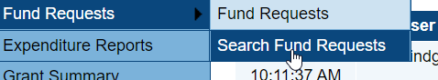
The Search Fund Requests screen has multiple criteria that can be used singly or in combination for locating fund requests. Hold down control and click on each item to select multiple items in a dropdown that allows multiple selections.

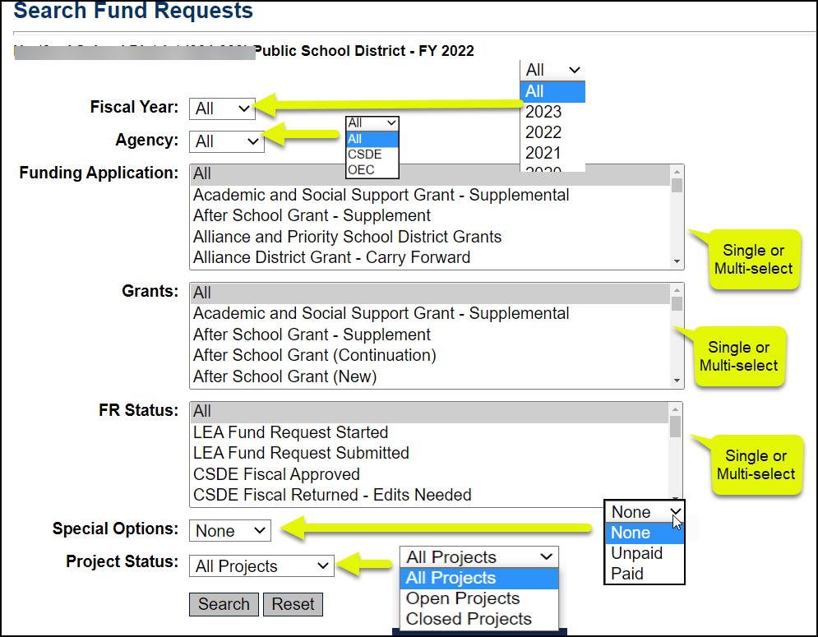

Note that the items returned in a Search can be downloaded to an Excel spreadsheet.

Examples of searches
- Search for requests that have been started but need attention
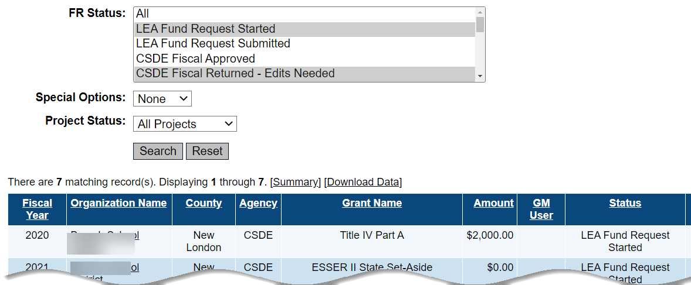
All Unpaid Requests
