Creating a Budget

- Make sure the application is in Application Started status.
- Go to the Budget page. Click on Modify in front of an object code.  Note: If no budget details have been created, you should see the Copy (year) Budget Detail link if the grant was in the system in the previous year. This will copy the previous year’s budget details into the budget and you can edit them for the current year as needed. | 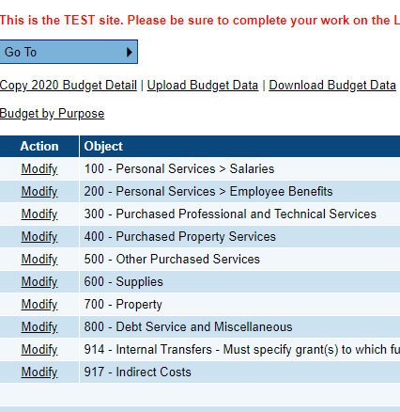
- 3. On the Budget Detail page, click on Add Budget Detail. | 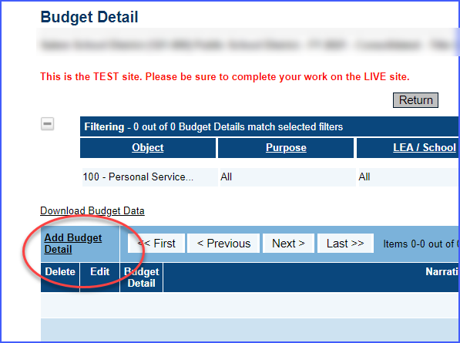
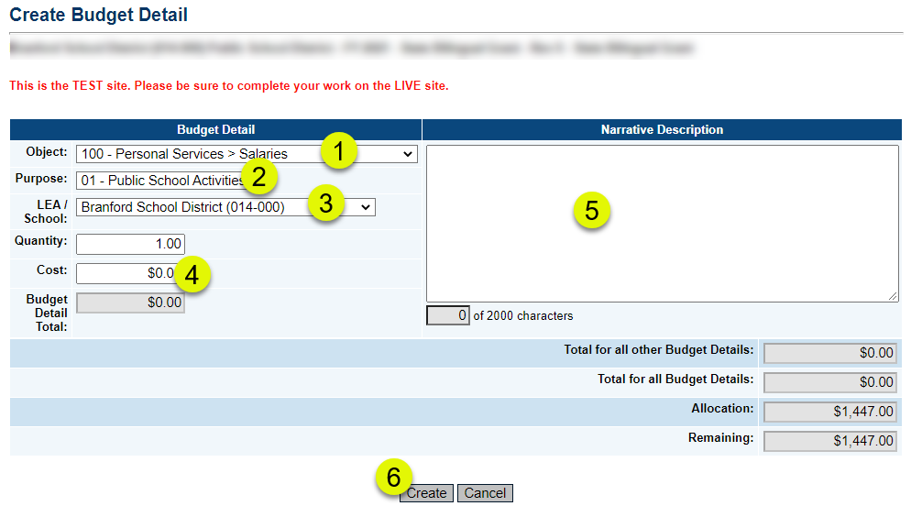

- If the Object code is not correct, use the drop down arrow to change it.
- If the Purpose is not correct, use the drop down arrow to change it.
- If you are budgeting at the school level, use the drop down arrow to select the school. (Note: Most grants leave this at the district level which is the default.)
- Leave the Quantity at 1 and enter the total amount for the budget item.
- Describe the purpose of the detail in the Narrative
- Click on Create to create the budget detail.
- Note: Some grants may have one or more budget tag groups, which is a way to identify budget details for a grant-specific requirement. The name of the tag group depends on the grant. If a selection of a tag is required, the instruction will read (Select at least 1 tag). If it is not required, it will read (Select up to 1 tag(s)).
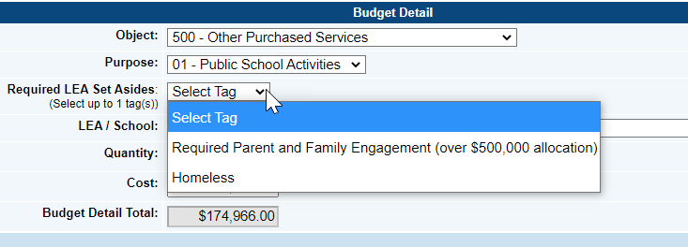

- To create another budget detail, click on Add Budget Detail again and select the desired object and purpose codes for the new detail.
- Repeat this process until the Remaining budget is 0. | 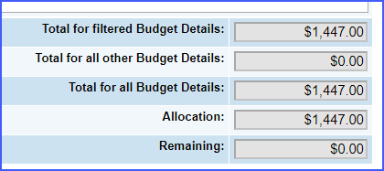

Changing a Budget Detail
- Locate the Budget Detail that needs to be edited.
- Click on the Edit pencil icon. | 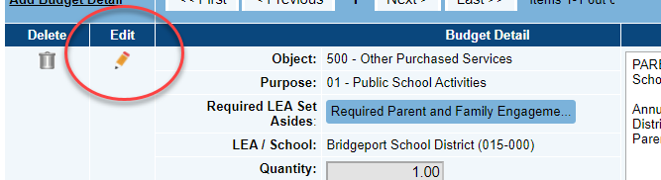
- Make the necessary changes to the detail and click on Update. Keep in mind that the cost must be greater than 0. If you no longer need the detail, it should be deleted.

Deleting a Budget Detail
- Locate the Budget Detail that needs to be deleted
- Click on the Delete trash can icon. | 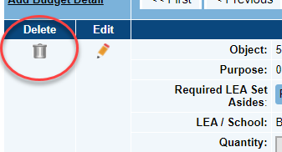
- Click on the Delete button. Note: there is no confirmation for the deletion. Pressing the Delete will immediately delete the detail.

