***Note: Only approved applications are viewable to the public. Application versions that are still in process will not be accessible.***

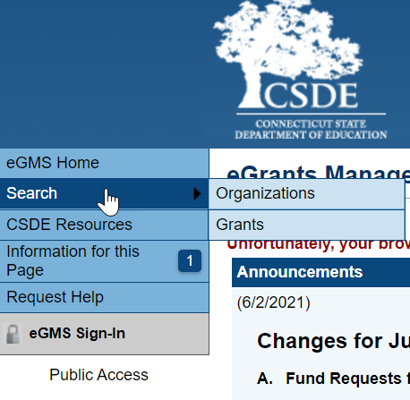

1. Go to the eGMS Home Page <https://connecticut.egrantsmanagement.com>. (This page also includes links to training videos and guides that will assist you in navigating the eGMS site.
2. On the upper left menu, select Search. You can search for a specific organization to view all their approved applications or you can search for a specific grant and see all the organizations with an approved application for the grant.

**To view approved applications for a specific organization or district**

1. 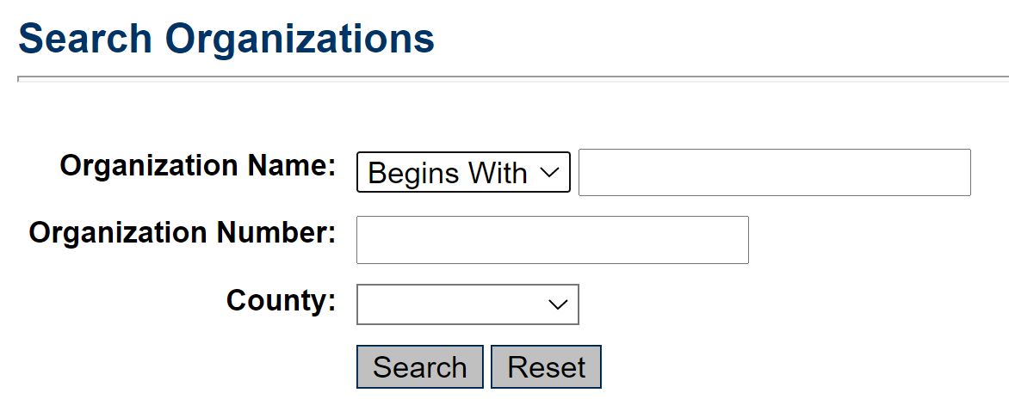Select Organizations from the submenu.
2. Enter the name or part of the name and click Search.
3. In the search returns, move to the column heading “Function” and select FA for Funding Application.
4. 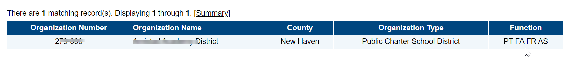In the search returns, move to the column heading “Function” and select FA for Funding Application.
5. On the Funding Applications page, select the Fiscal Year. (2021 refers to the 2020-2021 fiscal year)
6. Click on the grant name to open it.
7. Instructions for navigating within a grant can be found on the eGMS Home page in the Video and Training links section.

**To view all applications for a specific grant**

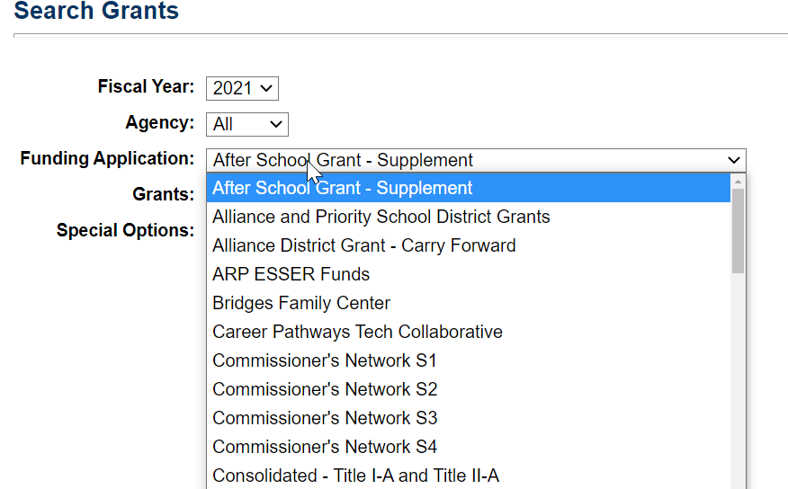

1. Select Grants from the submenu.
2. On the Search Grants screen, select the Fiscal Year, the Funding Application and the Grant. While the majority of funding applications contain only one grant, a few will contain multiple associated grants. The fiscal year indicates the ending period of the grant. (2021 is for fiscal year 2020-2021)

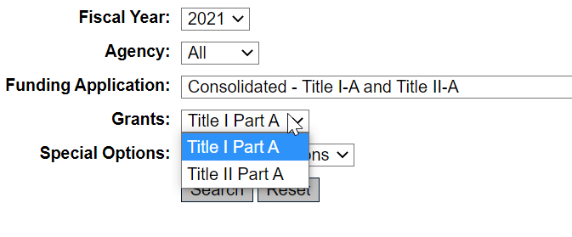

1. The search returns will include organizations that have an approved application for the funding application selected.
2. Click on the organization name to open the grant selected.

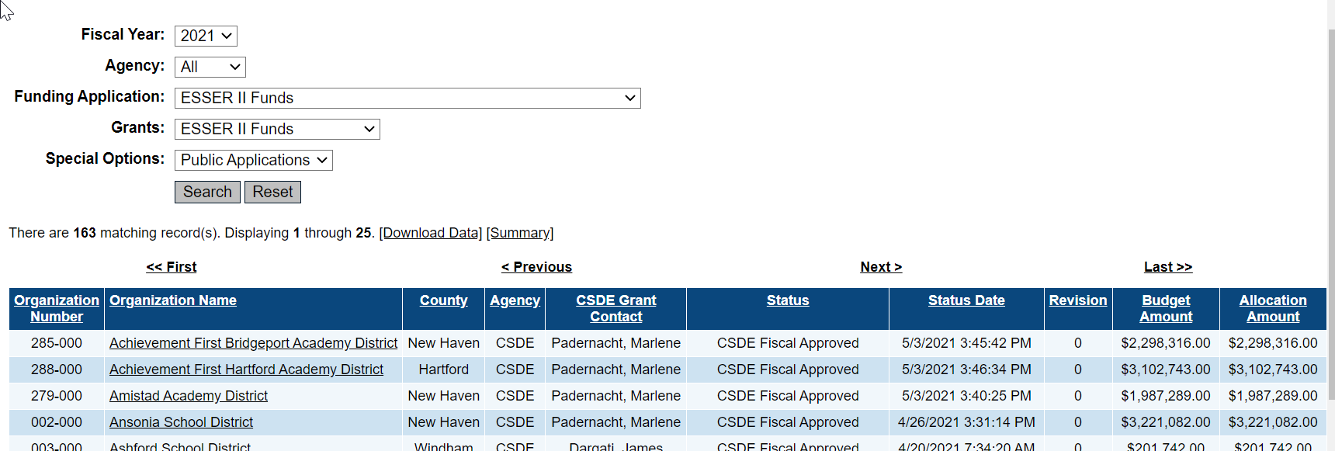

1. Instructions for navigating within a grant can be found on the eGMS Home page in the Video and Training Links section.